KAUNO TECHNOLOGIJOS UNIVERSITETAS

INFORMATIKOS FAKULTETAS

Programavimo kalbų teorija (P175B124)

Laboratorinių darbų ataskaita

Atliko:

IFF-1/9 gr. studentas

Martynas Kuliešius

2023 m. vasario 15 d.

Priėmė:

Lekt. Evaldas Guogis

Lekt. Tautvydas Fyleris

KAUNAS 2023

TURINYS

1. C++ arba Ruby (L1) Error! Bookmark not defined.

1.1. Darbo užduotis **Error! Bookmark not defined.**

1.2. Programos tekstas **Error! Bookmark not defined.**

1.3. Pradiniai duomenys ir rezultatai **Error! Bookmark not defined.**

2. Scala (L2) Error! Bookmark not defined.

3. Haskell (L3) Error! Bookmark not defined.

4. Prolog (L4) Error! Bookmark not defined.

1. **C++ arba Ruby (L1)**
   1. Darbo Užduotis

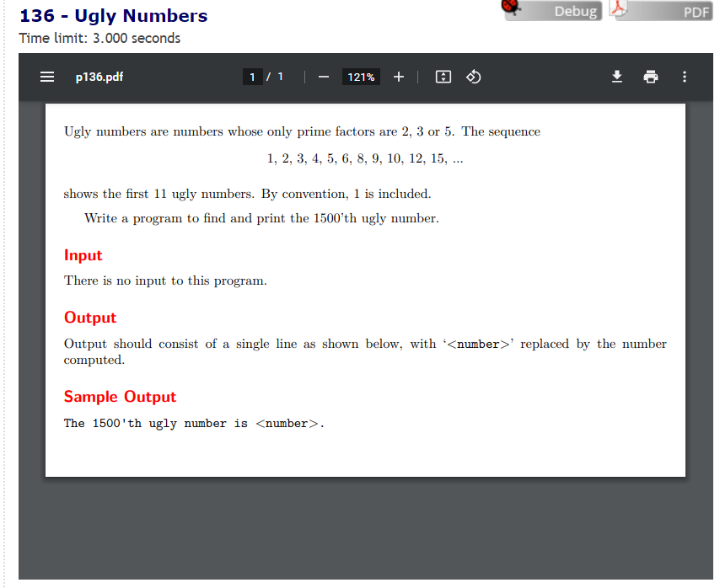

* 1. Programos Tekstas

Main.cpp failas:

// 136 - Ugly Numbers

// Martynas Kuliešius IFF-1/9 E**36

/*

Užduoties sąlyga:

Ugly numbers are numbers whose only prime factors are 2, 3 or 5. The sequence

1, 2, 3, 4, 5, 6, 8, 9, 10, 12, 15, ...

shows the first 11 ugly numbers. By convention, 1 is included.

Write a program to find and print the 1500’th ugly number.

--Input--

There is no input to this program.

--Output--

Output should consist of a single line as shown below, with ‘<number>’ replaced by the number

computed.

--Sample Output--

The 1500'th ugly number is <number>.

*/

#include <iostream>

#include <vector>

#include <chrono>

using namespace std;

/// <summary>

/// Class to declare methods and write their headers

/// </summary>

class Utils {

public:

/// <summary>

/// Gets the minimum value out of three integer values

/// </summary>

/// <param name="a">first integer value</param>

/// <param name="b">second integer value</param>

/// <param name="c">third integer value</param>

/// <returns>Returns minimum value of of three integer values</returns>

int getMin(int a, int b, int c);

/// <summary>

/// Returns the n-th ugly number

/// </summary>

/// <param name="n"> index/number of the ugly number wanted</param>

/// <returns> the wanted ugly number</returns>

int returnUglyNumber(int n);

};

class InOut {

public:

/// <summary>

/// Header of n input method

/// </summary>

/// <returns> the integer value for n </returns>

static int ReadN();

/// <summary>

/// header of method to print to screen.

/// </summary>

/// <param name="n"> the integer value for n </param>

/// <param name="uglyNumber"> the integer value for n-th ugly number </param>

static void PrintToScreen(int n, int uglyNumber);

};

int main() {

Utils workMethods; // create/declare class

InOut inOut; // create/declare class

chrono::time_point<std::chrono::system_clock> s, e; // start/end

int n = inOut.ReadN(); // the nth number we want

s = chrono::system_clock::now();

int uglyNumber = workMethods.returnUglyNumber(n); // n-th ugy numebr we want

e = chrono::system_clock::now();

inOut.PrintToScreen(n, uglyNumber); //output ugly number to screen

chrono::duration<double> time = e - s;

cout << endl << "Elapsed time: " << time.count() << " seconds" << endl;

return 0;

}

int Utils::getMin(int a, int b, int c) {

return min(min(a, b), c);

}

int Utils::returnUglyNumber(int n) {

vector<int> uglyNumbers(n); // array to store numbers

uglyNumbers[0] = 1;

//

int i2 = 0;

int i3 = 0;

int i5 = 0;

int nextMultipleOf2 = 2;

int nextMultipleOf3 = 3;

int nextMultipleOf5 = 5;

// for loop loops util i index reaches the value of n, thus creating n ugly numbers.

for (int i = 1; i < n; i++) {

int nextNumber = getMin(nextMultipleOf2, nextMultipleOf3, nextMultipleOf5);

uglyNumbers[i] = nextNumber;

if (nextNumber == nextMultipleOf2) {

i2++;

nextMultipleOf2 = uglyNumbers[i2] * 2;

}

if (nextNumber == nextMultipleOf3) {

i3++;

nextMultipleOf3 = uglyNumbers[i3] * 3;

}

if (nextNumber == nextMultipleOf5) {

i5++;

nextMultipleOf5 = uglyNumbers[i5] * 5;

}

}

return uglyNumbers[n - 1];

}

/// <summary>

/// Simple method to return n value

/// </summary>

/// <returns> the integer value of n </returns>

int InOut::ReadN() {

int n;

cout << "Write an integer value for which ugly number you want to get:";

cin >> n;

return n;

}

/// <summary>

/// Simple method to return the ugly number value

/// </summary>

/// <param name="n"> integer value of n </param>

/// <param name="uglyNumber"> integer value of the ugly number </param>

void InOut::PrintToScreen(int n, int uglyNumber) {

cout << n << "th ugly number is: " << uglyNumber << endl;

}

* 1. Pradiniai Duomenys ir Rezultatai

**Testas 1:**

Pirmajam testui nusprendžiau įvesti užduotyje nurodytą įvesties reikšmę: 1500.

Programa greitai suveikia ir per 0.0675 milisekundes duoda atsakymą: 859963392

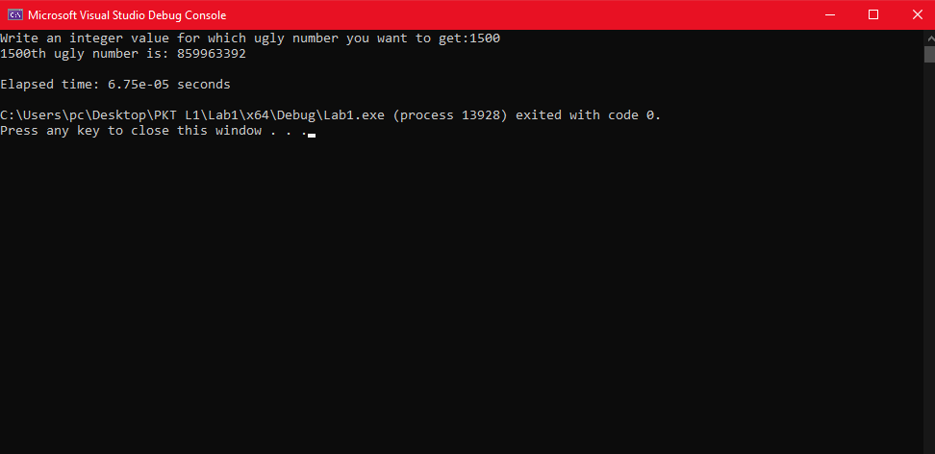

**Testas 2:**

Antrajam testui nutariau pasirinkti vieną iš duotų reikšmių: 10.

Programa greitai suveikia ir per 0.054 milisekundes duotą atsakymą: 12

